QPG6200 DevKit Notes:
Uses Matter (over Thread), Zigbee and Bluetooth Low Energy wireless connectivity standards.
SW available on GitLab - https://gitlab.com/qorvo_sdk/public/devkits/qpg6200-iot-sdk

Common Matter Devices : SWITCHES, LIGHTS, THERMOSTATS, DOOR LOCKS

ConcurrentConnectTM Technology:
- Multi-Radio: built into the QPG6200, it enables seamless and concurrent (simultaneous) use of Bluetooth and IEEE 802.15.4 for all use cases. This makes it easy to build multi-standard applications that simply work without additional complex SW configuration/time-multiplexing mechanisms.
- Multi-channel: enables the receiver for up to 3 IEEE 802.15.4 stacks concurrently, enabling running Zigbee and Matter over Thread concurrently.
- Antenna diversity: increases interference robustness and link budget, resulting in superior RF range for both IEEE 802.15.4 protocols and Bluetooth Low Energy through preamble-based antenna diversity built in the QPG6200 hardware.

Figure 1: DevKit Carrier & Radio Board Components
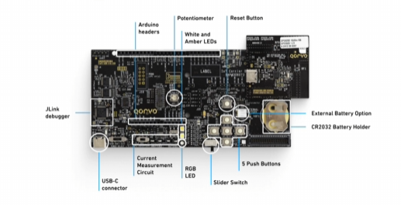

DOWNLOAD SOFTWARE DEV KIT (SDK) TUTORIAL (from Qorvo) - https://qorvo_sdk.gitlab.io/public/devkits/qpg6200-iot-sdk/QPG6200-IoT-SDK/2.1.0/sphinx/docs/QUICKSTART.html
- Recommended to use Dev Container as it allows you to work in a consistent environment across different machines and simplifies the setup process.

Personal Notes and Tips:
- Install VSCODE - https://code.visualstudio.com/download
  - Click the Extensions button on the side, then search, and download Dev Containers and Docker
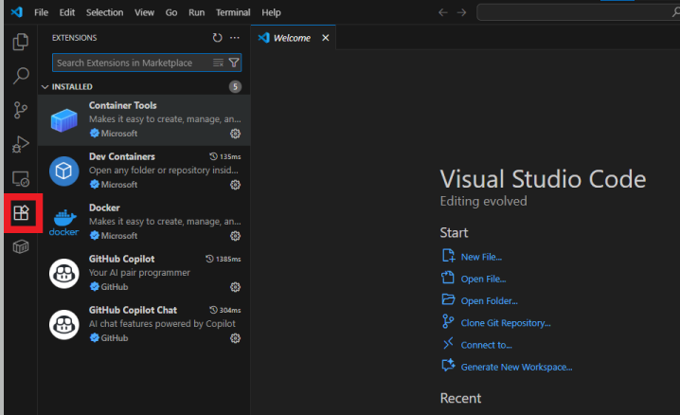
- Install Docker Desktop - https://docs.docker.com/desktop/setup/install/windows-install/
  - You may need to update WSL version - more info in link/figure below
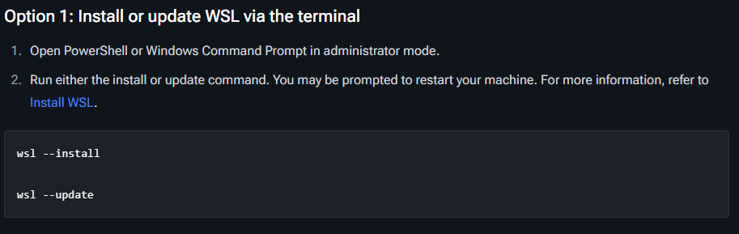
  - You may also need to enable virtualization in your BIOS menu (which you will need to restart and during the boot process, spam F8, F10, or DEL. It’s different for every PC/laptop so I don’t know which exactly). The BIOS menu will also look different for every user, so I recommend looking at a YouTube tutorial to find the Enable Virtualization option.
- Git clone Qorvo® IoT SDK folder https://gitlab.com/qorvo_sdk/public/devkits/qpg6200-iot-sdk
  - In the GitLab, Click Code & copy HTTPS URL
  - In VSCODE, click Terminal (top bar) -> New Terminal
  - Then, git clone <Insert URL>
  - You should see the folder qpg6200-iot-sdk when you press “Open Folder”
- There should be a prompt that allows you to select Reopen in Container. If not, you can type devcontainer in the top bar and press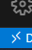 button (located on the bottom left). The figure below shows what happens when you press that button. This will also be how you can close the remote connection by pressing “Close Remote Location”.
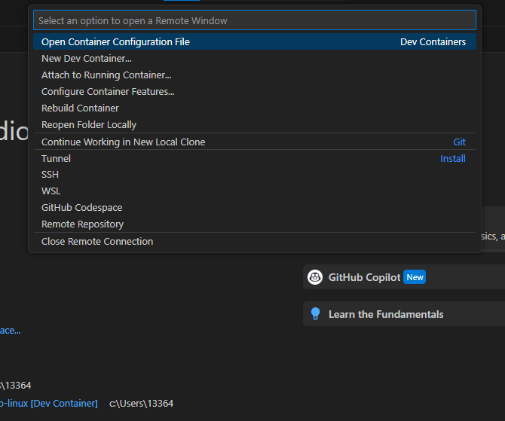
- Your SDK Dev Container is now ready for programming! Make sure you close the remote connection after (Instructions in step 4).

